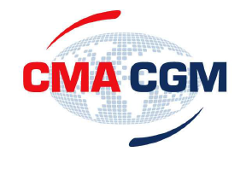

GENERAL RATE RESTORATION
Asia to West Africa
WESTBOUND

Effective May 1st 2012: increase of USD 250 / TEU.

In order to continue to provide the service necessary to meet their customers’ needs,
CMA CGM has decided to implement the rate restoration on the
Far East - West Africa trade as from May 1st.

