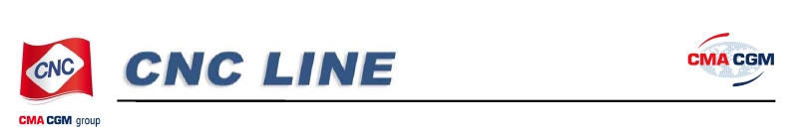
Taipei - FEB 22nd, 2012
CNC & CMA CGM Intra Asia announces
Emergency Bunker Surcharge for
all China ports to Intra Asia(AOTJ)
outbound laden shipment
CNC & CMA CGM Intra-Asia have decided to adjust the
Emergency Bunker Surcharge (EBS) quantum for all China
outbound laden shipment to Intra Asia (Any Other Than Japan)
with following effective date and will be collected at loading port.
Effective date: March 1st , 2012 (sailing date).
The EBS quantum is as follows:
USD200 per teu for all China ports to Intra Asia(AOTJ)
cargos.

