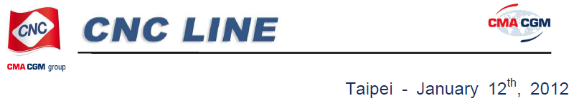
CNC & CMA CGM announce a
new China THC implementation
for East India cargo
CNC & CMA CGM Intra Asia have decided to adjust a new China
THC for all laden shipments to/from East India.
The new tariff will be effective as from Feburary 1st, 2012 (On
board date).
The new tariff is as follows:
THC
RMB 755/1090/1417 for 20’/40’(HQ)/45’ – Dry container
RMB 820/1280 for 20’/40’(HQ) – Reefer container
RMB 820/1280 for 20’/40’(HQ) – OT,FR(in gauge)

